A REPORT OF MINI-PROJECT

“Building a Secure SaaS Platform Over LAN
Using HDFS and AES Encryption”

SUBMITTED TO THE SAVITRIBAI PHULE PUNE UNIVERSITY, PUNE
IN PARTIAL FULFILLMENT OF THE REQUIREMENTS
FOR THE THIRD YEAR OF THE DEGREE

BACHELOR OF ENGINEERING
In
COMPUTER ENGINEERING
By

Under the guidance of



DEPARTMENT OF COMPUTER ENGINEERING
SINHGAD COLLEGE OF ENGINEERING,PUNE-41

Accredited by NAAC with A+ Grade

2024-25


Sinhgad Technical Education
Society,
Sinhgad College of Engineering,
Pune-41 Department of Computer Engineering
Date :

CERTIFICATE

This is to certify that the Mini Project Report entitled

“ Building a Secure SaaS Platform Over LAN Using HDFS and AES Encryption”
Submitted by

TEJAS KAILAS PATIL
Roll No : 305B039 Exam Seat No: T1902304370

This is a curriculum-based Cloud Computing Mini Project work carried out, under the guidance of Prof. Laxman Pawar, for the partial fulfilment of the requirements of Savitribai Phule Pune University, Pune, for the third year of the degree of Bachelor of Engineering (Computer Engineering) during the year 2024-25.

Prof. Laxman Pawar  Guide  Department of Computer Engineering | Dr. M. P. Wankhade Head  Department of Computer Engineering

Dr. S. D. Lokhande Principal
Sinhgad College of Engineering

Acknowledgment

I would like to express my heartfelt gratitude to my project guide and mentor, Prof Laxman Pawar, whose unwavering support, insightful feedback, and valuable suggestions played a pivotal role in the successful completion of this project. Their guidance helped me remain focused and motivated throughout the development and implementation phases.
I am also thankful to the staff of the computer science laboratory for providing the necessary infrastructure and assistance required to carry out this project smoothly. I extend my gratitude to my classmates and friends for their constant encouragement, meaningful discussions, and collaborative spirit.
Finally, I am deeply grateful to the open-source software community, whose tools and libraries were indispensable in developing the custom cloud controller and integrating it with HDFS. Their contributions to technology democratization made this project possible.

Abstract
The rapid growth of cloud computing technologies has transformed traditional IT infrastructure by offering scalable, on-demand, and secure services. This project focuses on simulating a cloud-based Software as a Service (SaaS) environment over a Local Area Network (LAN) by developing a custom cloud controller that interfaces with the Hadoop Distributed File System (HDFS). The system enables users to upload and download files in an encrypted format, ensuring data privacy and security within the network.
Key functionalities include file segmentation, AES encryption, secure file storage on HDFS, and seamless file retrieval. The controller is responsible for managing encryption/decryption, HDFS integration, and metadata organization. Designed using open-source technologies such as Python/Java, Flask/Spring Boot, and Hadoop, the system is lightweight, cost-effective, and ideal for academic and small organizational environments. This project demonstrates the practical implementation of cloud principles within a LAN and provides a foundational platform for further cloud-based innovations.

Contents
Acknowledgment Abstract
Chapter 1: Introduction 1
Chapter 2: Objectives 2
Chapter 3: System Architecture… …3
Chapter 4: Software and Hardware Requirements 4
Chapter 5: Implementation 5
Chapter 6: Results 6
Chapter 7: Conclusion 8
Chapter 8: References 9

Chapter 1

Introduction
In today’s data-driven world, cloud computing has become the backbone of modern IT infrastructure, offering flexible services such as Infrastructure as a Service (IaaS), Platform as a Service (PaaS), and Software as a Service (SaaS). Among these, SaaS has gained immense popularity due to its simplicity and ability to deliver software applications over the internet or internal networks.
This project explores the creation of a private SaaS platform deployed over a LAN, where the goal is to provide secure and efficient file storage and retrieval services using open- source components. By integrating a custom-built cloud controller with HDFS, we aim to develop a system that supports encrypted file storage, efficient data handling, and secure communications within a local setup.
The project’s key innovation lies in the custom cloud controller that performs the following functions:
- Splitting files into manageable segments
- Encrypting segments using AES for confidentiality
- Uploading encrypted blocks to HDFS
- Handling user requests for downloading and decrypting files
The motivation behind this project stems from the need for secure data solutions in environments like schools, labs, and small enterprises, where internet access may be limited, and data sensitivity is high. By using LAN for deployment and HDFS for storage, this project ensures data availability, integrity, and confidentiality within a controlled and private network environment.
This report details the system’s design, architecture, implementation, and testing, and provides insights into its performance and scalability. It also discusses the challenges faced, lessons learned, and potential areas for enhancement.

Objectives

To develop a secure and functional SaaS environment over LAN:
  - Design a private cloud-like infrastructure tailored for LAN setups, suitable for educational institutions or small organizations.

To implement a custom cloud controller:
  - Build a lightweight and modular cloud controller that facilitates core cloud operations such as file upload, segmentation, encryption, metadata handling, and download.

To ensure secure data transmission and storage:
  - Utilize AES encryption to guarantee confidentiality of user data during both upload and download processes.
  - Protect files from unauthorized access while stored on HDFS.

To integrate with Hadoop Distributed File System (HDFS):
  - Utilize HDFS for its reliability, scalability, and distributed nature to store encrypted file segments across the LAN.

To simplify file handling through automation and APIs:
  - Develop user-friendly REST APIs for interaction, making the system accessible through web interfaces or programmatically.

To validate system performance in a controlled lab environment:
  - Conduct tests on various file sizes and types to ensure data integrity, reliable encryption/decryption, and proper storage in HDFS.

To create a scalable and modular architecture:
  - Lay a foundation for future enhancements such as user authentication, dashboards, and role-based access.
Chapter 3
System Architecture

Components:
    - Client Interface: Provides endpoints for uploading and downloading files.
    - Cloud Controller: Handles file operations including segmentation, encryption, metadata handling, and interaction with HDFS.
    - HDFS: Stores encrypted file segments in a distributed manner.
    - LAN: Facilitates communication between client and controller.

Architecture Workflow:
- User selects and uploads a file through the interface.
- File is divided into blocks of fixed size (e.g., 1MB).
- Each block is encrypted using AES.
- Encrypted blocks are uploaded to HDFS via the controller.
- Metadata is stored for each file (e.g., block names, keys, order).
- On download request, blocks are retrieved, decrypted, and reassembled into the original file.

Chapter 4
Software and Hardware Requirements
  - Software Requirements:
    - Operating System: Ubuntu 20.04 LTS / Windows 10 / macOS (for development)
    - Programming Language: Java / Python
    - Frameworks:
      - Flask (for Python-based implementation)
      - Spring Boot (for Java-based implementation)
    - Hadoop: Version 3.x with HDFS enabled
    - Java Development Kit (JDK): Version 8 or above
    - IDE/Editor: IntelliJ IDEA, VS Code, Eclipse
    - Build Tools: Maven / Gradle (for Java)
    - Database (optional): MongoDB / MySQL for metadata storage
    - Encryption Library: PyCrypto, Javax.crypto, or similar
    - Postman: For testing REST APIs
    - Docker (optional): For containerized deployment

  - Hardware Requirements:
    - Processor: Intel i5 or above (or equivalent AMD)
    - RAM: Minimum 8 GB (16 GB recommended for HDFS and IDE usage)
    - Hard Disk: Minimum 100 GB free space
    - Network: High-speed LAN connectivity with stable switches/routers
    - Systems: At least 3 nodes (1 NameNode and 2 DataNodes) for HDFS cluster setup
    - Other: UPS/inverter backup for power stability during HDFS operations

Chapter 5
Implementation
The implementation of the project is divided into the following modules:
  - File Upload and Segmentation Module:
    - The user selects a file through a web interface or command-line utility.
    - The file is read in chunks (e.g., 64 KB each) and segmented.
    - Each segment is temporarily stored in memory or buffer before encryption.
  - Encryption Module:
    - AES (Advanced Encryption Standard) with a 128/256-bit key is used for encryption.
    - A unique key is either generated or predefined for the session.
    - Each file segment is encrypted using the AES key.
    - Metadata about the file (e.g., file name, number of segments, encryption status) is stored in a database.
  - HDFS Upload Module:
    - The encrypted segments are uploaded to HDFS using Hadoop's file system API.
    - Each segment is saved as a unique block file in the HDFS directory structure.
    - Block IDs and mapping are stored in metadata for reference during download.
  - File Retrieval and Decryption Module:
    - On download request, block files are fetched from HDFS using metadata.
    - The segments are decrypted using the AES key.
    - The decrypted segments are combined in the correct order to reconstruct the original file.
  - REST API Module:
    - Developed using Flask (Python) or Spring Boot (Java).
    - Provides endpoints like /upload, /download, /status, etc.
    - Each request is validated and logged for transparency and debugging.

  - User Interface (Optional):
    - A minimal web-based interface for file upload/download.
    - Displays upload progress, download history, and file status.
  - Error Handling and Logging:
    - Logs are generated for every critical operation (upload, encrypt, write to HDFS).
    - Errors are logged with appropriate codes and timestamps.
    - Retry mechanisms are implemented for failed uploads or downloads.

Chapter 6

Results

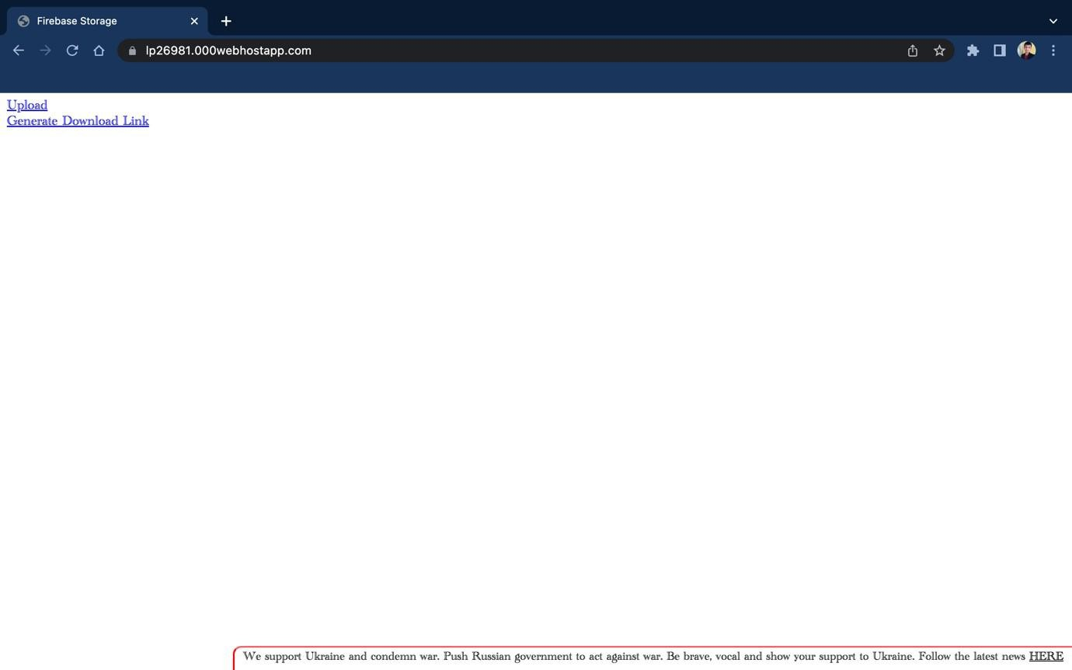

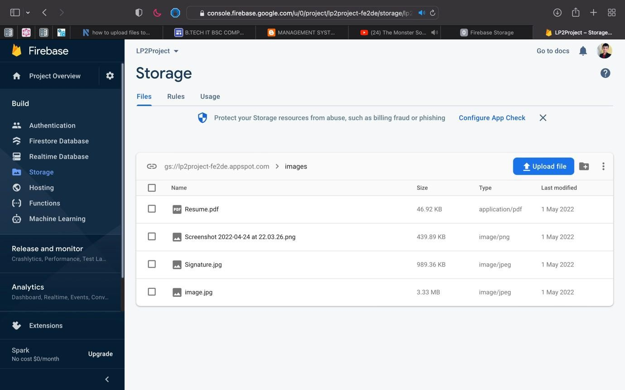
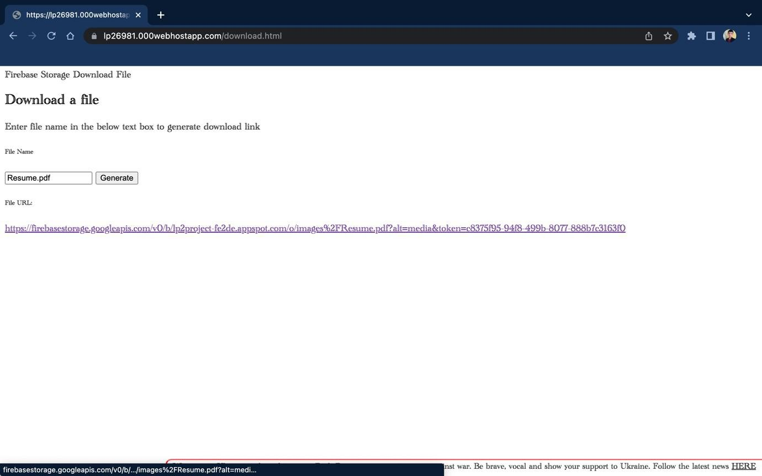

Chapter 7
Conclusion
This project successfully demonstrates the feasibility of setting up a private cloud-like Software as a Service (SaaS) platform over a Local Area Network using open-source technologies and HDFS. By developing a custom cloud controller capable of encrypting files, segmenting them, and storing them securely in a distributed environment, we addressed core challenges related to data privacy, secure access, and fault tolerance.

The use of AES encryption ensures that sensitive files remain protected during transmission and while at rest. Integration with HDFS brings scalability and redundancy to the system. Our modular design approach, RESTful APIs, and optional user interface provide flexibility for users and developers alike.
This setup serves as a scalable foundation that can be expanded with features such as user authentication, monitoring dashboards, access control, or even integration with cloud platforms. The project proves valuable not only for academic learning but also for real- world applications in secure LAN-based environments.

Chapter 8

References
- Apache Hadoop Documentation – https://hadoop.apache.org/docs

- Java Cryptography Architecture –
https://docs.oracle.com/javase/8/docs/technotes/guides/security/crypto/CryptoSpec.ht ml
- Flask Framework – https://flask.palletsprojects.com/

- Spring Boot Documentation – https://spring.io/projects/spring-boot

- AES Encryption Standard –
https://nvlpubs.nist.gov/nistpubs/FIPS/NIST.FIPS.197.pdf

- PyCrypto Documentation – https://pypi.org/project/pycrypto/

- HDFS Architecture Guide – https://hadoop.apache.org/docs/stable/hadoop-project- dist/hadoop-hdfs/HdfsDesign.html
- RESTful API Design – https://restfulapi.net/

